Mansi kaushik

18csu125

Lab experiments

**Experiment 1:**

**Installation of Cygwin:**

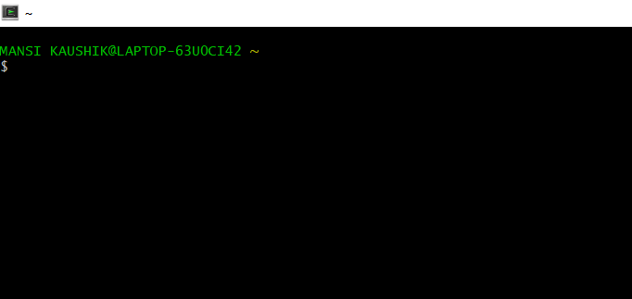

**Experiment 2:**

**Linux Commands:**

